Rie Hasegawa

Quiz01

Mobile 20/03/2023

1.Reverse Engineering

Save the APK folder in your explore. Then store that with your Revers Engineering tools.

Then, type “cmd” on the path zone. Cmd will open, type command “java -jar apktool_2.7.0.jar d quiz01.apk -o quiz01-decompiled”. That is command for decompiling the Apk file. d for decompile, -o for output location.

Unzip the Apk file to find classes.dex file.

And copy the classes.dex file on dex-tools-2.1.

Type “cmd” on the path banner, the open the Cmd, type “d2j-dex2jar.bat classes.dex”.

Go to jd-gui, open file, choose classes-d2jar file.

Done.

2.Static Code Review

a. manifest -> activity

b. resources, components, manifest, build configurations

c. manifest -> action and category

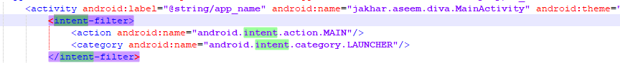

d. use to specify the type of intent that the component would like to receive.

e. implicit intent and explicit intent

f. Main activity,